KELOMPOK STUDI TIROIDOLOGI INDONESIA
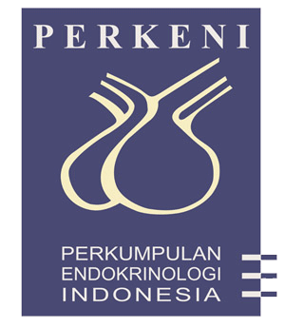
The Indonesian Study Group of Thyroidology

Jalan Pasirkaliki 192 Tel. +62 22-2039592 Fax. +62 22-2041337
KELOMPOK STUDI TIROIDOLOGI INDONESIA
Bandung 40161 Indonesia E-mail : indothyro@yahoo.com

The Indonesian Study Group of Thyroidology

Honorary Chairman : RRJ Djokomoeljanto
Chairman : Johan S. Masjhur
Vice Chairman : Imam Subekti
Tjokorda GD Pemayun
Secretary : Augusta YL Arifin
Dante Saksono Harbuwono
Treasurer : Ida Ayu Kshanti
Nanny Natalia Soetedjo

Expert Committee : Sri Hartini KS Kariadi
Sarwono Waspadji
Syafril Syahbuddin
John MF Adam
H. Muchlis Ramli
Ketut Suastika
H. Asdie
Djoko Wahono Soeatmadji
Agung Pranoto
Working Groups (Coordinators)
- IDD & Epidemiology : Tjokorda GD Pemayun
Djoko Kartono
- Thyroid Malignancy : H. Muchlis Ramli
Johan S. Masjhur
Dimyati Achmad
- Thyroid and Pregnancy : Sri Hartini KS Kariadi
- Thyroid Autoimmunity : Harsinen Sanusi
Imam Subekti
Dante Saksono Harbuwono
- Clinical Thyroidology : JMF Adam
Ketut Suastika
Ari Sutjahjo
- Molecular Thyroidology : Djoko W. Soeatmadji
Agung Pranoto
Heri Nugroho
- Congenital Hypothyroidism : Diet S. Rustama
- Thyroid Orbitopathy : Marie Sempelan Adam

==0==

